Zhongyi laser Carving Machine
Model: ZYX-C03

Software Manual
（ZYTYPE 3.0）

Changzhou Zhongyi Computer Systems Research Institute

Function
Description of carving machine software
As driver for carving machines, the current software supports documents in BMP. JPG, DXF, PCL5 printer, sing/rubber from Korea and our own files.
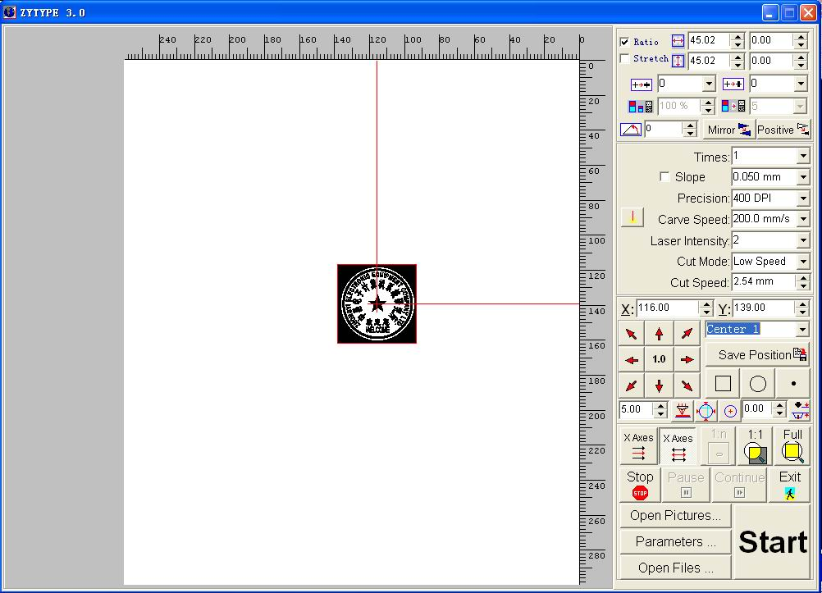
The interface is illustrated as follows:
1
2
3
4
5
6
7
9
10
11
12
14
15
16
17
18
19
20
21
22
23
24
25
26
27
28
29
30
31
32
33
34
35
8
13
36
- Picture width, height
The data in sizes of loaded pictures can be modified by entering sizes.
- Width and height of work-piece
The width and height will be displayed as it is measured. (no modification can be made the width or height of work-piece.)
- Pictures can be zoomed in and out at the proportion.
- Automatically replace the picture width, height with work-piece width and height accordingly.
- making horizontal and vertical bold
Due to the wear off in carving, perfect effects can be achieved by making horizontal and vertical bold.
- Stretch Scale
- GrayPicuter Convertion Mode
- Rotation
The picture can rotate to a certain degree for carving
- left and right mirror image
- Reversing of
- Carving times
Indicates the frequency for carving a work-piece continuously. Succeeding carving will be bolded on its last carving.
- Carving slope
This controls picture strokes and texture slope in the carving process. This software controls the slope carving through laser magnitude resulted from the movement of moving mechanism, which in turn determines width of slope together with carving current and preset current (see above diagram)
- Slope control switch
- Resolution
There are many resolutions in this carving, The higher resolution, the better carving results and longer time is required. When cutting, it automatically selects 1000DPI for running.
- Carving speed
There are 10 carving speeds which can be adjusted in the speed set.
- Current testing buttons
Observe the panel ampmeter for about 2 minutes for testing carving current selected. If more time needed for observation, press down the green switch on the panel.
- Carving current
There are altogether 16 grades of current values(1,2,3,4,…16) which correspond to 0 mA To 20mA (no need to have even intervals)and the current can be adjusted by each grade.(use potentialmeter to control on the board, clockwise rotation indicates increase, see above diagram). Grade one is pre-electro-ion, grade 2 corresponding to panel potentialmeter).
- Cutmode
Low speed，Updown speed，Uniform speed
- Cutting speed
In order to obtain best cutting results, it is suggested that cutting speed shall not be very high.
- positioning
Indicates the position(x,y) of pictures in the carving and can be modified by entering values.
- Positioning options
There are 7 positioning options, Center 1,2,3, lower left, lower right, upper left, upper right corresponding to different fixtures for rectangular and round seals. Normally, rectangular seals will apply lower left positioning, round or elipitical seals apply to central positioning option. Pressing F5 key will change options. Position for each positioning option will be stored in the system.
- Button for storing modified positioning data
- Accurate positioning
In order to make the positioning change accurate, you may click the up, low, left and right green buttons to accurately move the picture positioning outline. Movement intervals can be set by pressing buttons. The range of intervals are 0.05㎜、0.1mm、1.0mm、5.0mm；This is also the interval for dragging picture positioning outline.
- Laser positioning
By pressing corresponding buttons may draw the outline, circle or points to help adjusting positioning. Laser intensity shall be positioning intensity (normally grade 2, and can be manually adjusted)
- Z-axis position display
Displays the current Z-axis position, position value can be entered directly.
Button for moving Z-axis position as indicated by scale.
- Move the probe to the work-piece center
Move the probe to the center of the work-piece according to positioning.
- Find the work-piece size and its center
Move the probe to the work-piece by pressing positioning button, press this button, the system will automatically find the work-piece width, height and positioning. Normally, testing work-piece size requires position to be in the center. First testing will find out the accurate positioning and size (error will appear). The second testing will find out the accurate size when it is in the accurate position.
- Testing of carving surface button
Move the probe to the work-piece by pressing positioning button, press this button, Z-axis will automatically move to the carving surface of the work-piece.
- Monitor function buttons
three options: positioning, actual size, full screen
Positioning button: display the positioning
Actual size button: due to the fact the carving surface is too large, the picture shown on the monitor has been zoomed out which may not be clear. By pressing this button, you will return to its original size to verify the picture
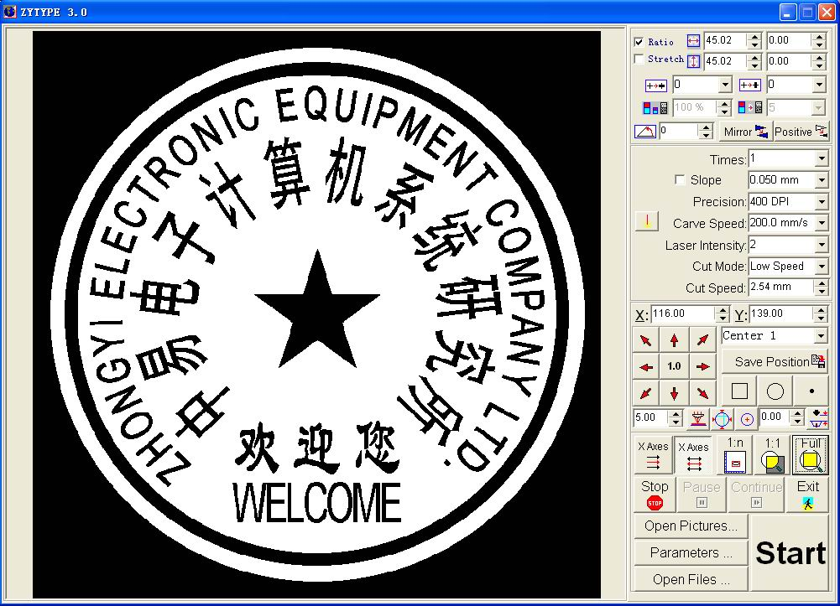
Full screen button: you will see the original of whole picture by pressing this button as illustrated above.
- Carving options
There are 2 carving options: one-way X, two-way X.
- stop, pause, continue and exit buttons
- open picture button
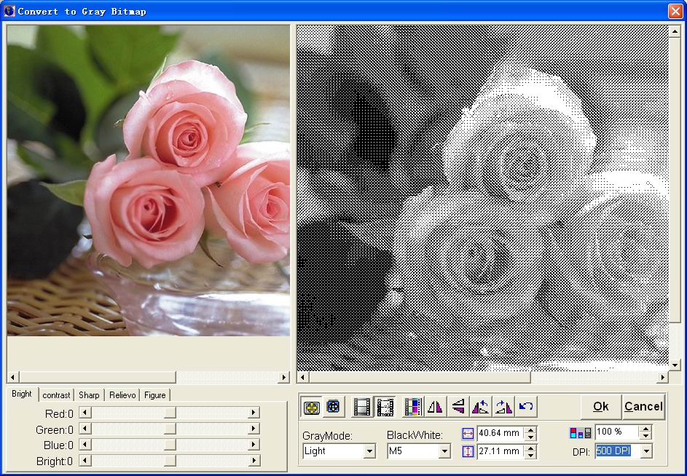
When a true color picture is opened, system will automatically skip out of the window for easy color picture carving.
- Parameter set-up buttons
These buttons will enable you to set parameters to achieve desired carving. Refer to the next chapter for detail instructions.
- Loading file button
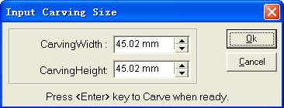
- Carving button
When carving button is pressed, above will be prompted for carving.
- Current picture outline positioning
Pressing positioning and positioning options to display picture position. Dragging picture positioning outline can also change positioning.

System Parameter Set-up
There are 7 sub-functions for parameter setup: 0nstart,orientation, carving, cutting, speed,Z axes,property.
- Onstart
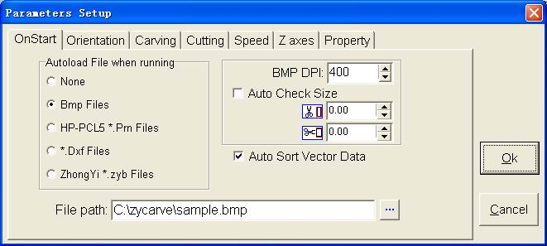
As shown above, this will let the computer automatically load in a certain file when starting for ease operation.
- Orientation
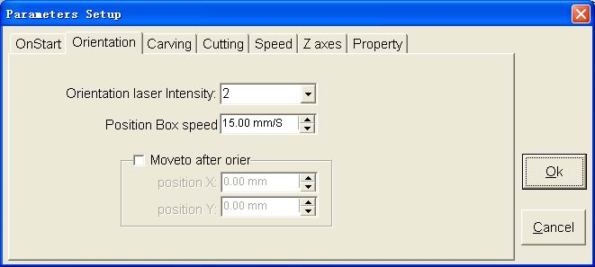
As illustrated above, includes laser intensity ( normally grade 2, corresponding to panel potential meter),speed of draw position box, position after orientation .
- Carving
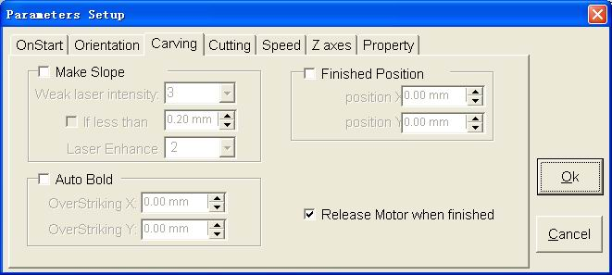
As shown above:
Weak laser current: setting the current value to decide carving slope width.
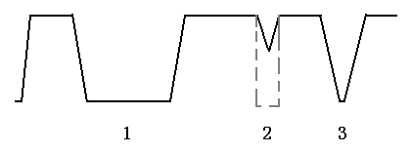Slope parameters：Carving setting，There will be three types of slope after carving. (as illustrated in Fig.). As for Fig., the part to be carved is too short will may result in the unclear picture or strokes uncarved which will affect the perfection of carving. To overcome this, when the carving distance is less than a certain value the laser magnitude will be increased to achieve perfection (no longer carving slope as illustrated in the Fig)
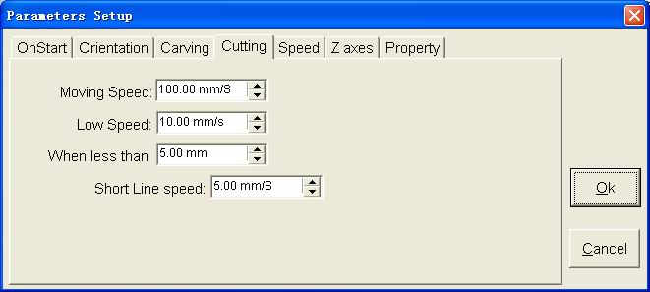
- Cutting
- Speed
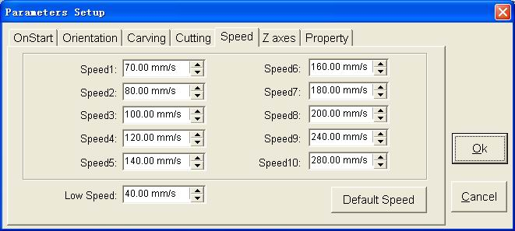
Low speed: to ensure smooth cart movement, speed variation must be done when change X,Y orientations. If the speed is too low, the cart movement is smooth, but it takes a longer time to adjust to required speed which will affect the performance. If speed is too high, there will be vibration and movement loss. In short, speed shall be set as needed.
Speeds 1-10 can be selected randomly but is limited by the low speed to some extent.
- Z axes
As illustrated, it would be very difficult to get the above parameter values by using measuring instruments, instead the below can be applied
Focusing surface (H)：To the same machine, the focusing surface and its position is relatively fixed and the position of focusing surface remains unchanged. Generally, the fixture surface shall be adjusted to the focusing surface (for testing of focusing surface, please refer to the Manual for installation and Maintenance.); modifying this value can result in change of Z-axis scale relative to coordinate 0, letting fixture surface lifted to overlap focusing surface for ease operation.
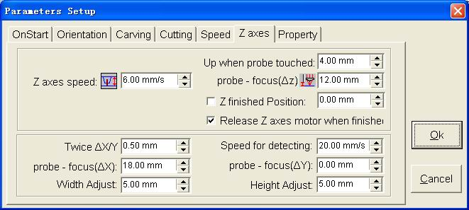
Probe lift distance (s): the distance lifted is normally 3mm after work-piece contacts the probe when testing the work-piece size and center. It will remain unchanged afterwards, otherwise it will affect the work-piece size and its position.
Z-axis movement speed: normally it shall not be changed after it is set. Otherwise it will affect the size and position of the test piece.
Release of Z-axis: make sure whether Z-axis is release or not after each movement of Z-axis. X,Y speed: the speed for X, Y when testing work-piece size and its center X、Y are 40mm/s. After it is set, it is recommended not to change otherwise it will affect the size and center position.
Width and Height error (2A, 2B): when the value is o, the difference between actual size and its measured value are width and height error respectively. When the probe is uplifted and there is change in X, Y, the error will vary accordingly.
Relative position between probe and focus point △X、△Y、△Z：
When△X,△Y are 0，use Laser positioning (outline, circle and point), work-piece size and center to detect work-piece position, the difference will be △X △Y to be set.
When △Z is 0，use chassis frame to test the fixture, the absolute value on Z-axis is △Z.
Notes：If there is error for the above parameters, fine adjustment shall be done until the error is within the minimum range such as ±0.05mm。
- Property
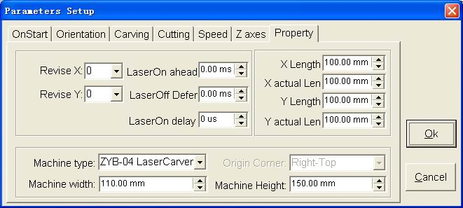
Error-offsetting X: adjusting may change roughness of X-cutting contour
Error-offsetting Y: adjusting may change roughness of X-cutting contour.

